# PYTHON PROJECT

## PROJECT NAME : ALL IN ONE CHATBOT

* SUBMITTING TO :

## Mr. Mayur Dev Sewak General Manager , Operations Eisystems Services

* 1. Ms. Mallika Srivastava

## Trainer , Programming & Algorithms, Eisystems Services

* + 1. SUBMITTING BY:

##################### #######################

# Content Table

|  |  |  |
| --- | --- | --- |
| **Serial No.** | **Title** | **Page No.** |
| **1.** | **Cover page** | **1** |
| **2.** | **Content table** | **2** |
| **3.** | **List of figures** | **2** |
| **4.** | **Abstract of project** | **3** |
| **5.** | **Project summary** | **3** |
| **6.** | **Objectives of Project** | **4** |
| **7.** | **Details of project developed** | **4** |
| **8.** | **System Requirements used** | **6** |
| **9.** | **Data Flow Diagram** | **6** |
| **10.** | **Input/output datasets** | **7** |
| **11.** | **Text code/program** | **15** |
| **12.** | **References** | **17** |

**List of Figures**

1. Details of Project developed :
   * Caption : Details of Project developed
   * Page No : 5
   * Figure No:1
2. Data Flow Diagram:
   * Caption : Data Flow Diagram
   * Page No : 6
   * Figure No:2

# Abstract of Project

## Project Title : All In One Chatbot

* Chatbots, or conversational interfaces as they are also known, present a new way for individuals to interact with computer systems.
* Traditionally, to get a question answered by a software program involved using a search engine, or filling out a form.
* A chatbot allows a user to simply ask questions in the same manner that they would address a human.
* *All in one chatbot* allows user to access particular website within a blink of an eye.
* *All in one chatbot* allows user to make payments , access data from Wikipedia or google , make bill payments. It also allows user to play online game. It also provides weather forecast report and calculator in just one click.

# Project Summary

## Project Title : All In One Chatbot

* Chatbot are tiny programs that help simulate interactions with customers automatically based on a set of predefined conditions , triggers, and/or events.
* There are several advantages to using All in one chatbot :

1. They can be proactive and reactive.
2. Their responses are consistent every time.
3. They can respond immediately.
4. They can help you collect important data and also learn from the data collected.
5. They can be used through a variety of different mediums like sms, live chat or even social media.

# Objectives Of Project

* A chatbot is a program that communicates with you.
* *All in one chatbot* provides daily routine services to user.
* *All in one chatbot* can access Wikipedia for accessing any article.
* It can also access google for more information.
* It can also make payments through phone-pe in just one click.
* *All in one chatbot* can also order online food.
* It can give weather report .
* The main objective of *All in one chatbot* is to provides all services to the end user in just one click. User can explore various websites using *All in one chatbot.*
* Weather forecast , social media , online food , online game ,online calculator ,Wikipedia

,google etc. are provided in *All in one chatbot*.

# Details of project developed

* It is a type of a software used to interact with humans in different languages through different mobile apps, websites, messages , etc.
* The standard form of the bot is “Build-operate-transfer”.
* There are seven steps to design the chatbot project. They are scope & requirement, Identify the input , understand UI elements , craft first interaction , build conversation , testing.
* The first step to designing a chatbot is to know the scope and requirements like why chatbot ,platform to launch chatbots and it’s limitations.
* The second step is to identify the inputs from users in the form of text .
* The third step is to understand the UI elements.
* UI elements are of five types : Command Line (CL), Graphical User Interface(GUI), Menu-Driven Interface(MDI), Form Based Interface(FBI), and Natural Language Interface(NLI).
* After understanding user interface element, the next step is to craft the first interaction and build a conversion.
* The final step of chatbot design process is testing , which is done on mobile and websites to know how it’s working.

Identify the input

Understand UI element

Craft first interaction

Build Conversation

Testing

Scope and Requirements

Fig. Details of Project Developed

# System Requirement Used

.

Test

Expression

.

1

Test

Expression

Statement 3

2

**-**

**-**

END

Test Expr n

Statement 4

1. Windows 10 pro
2. Python 3
3. PyCharm IDE
4. Command prompt

# Data flow Diagram / Algorithm

START

Def send():

Statement 1

Statement 2

Statement just

Below if-else ladder

**Input Output Datasets / screenshots**

1. How to open All In One Chatbot?

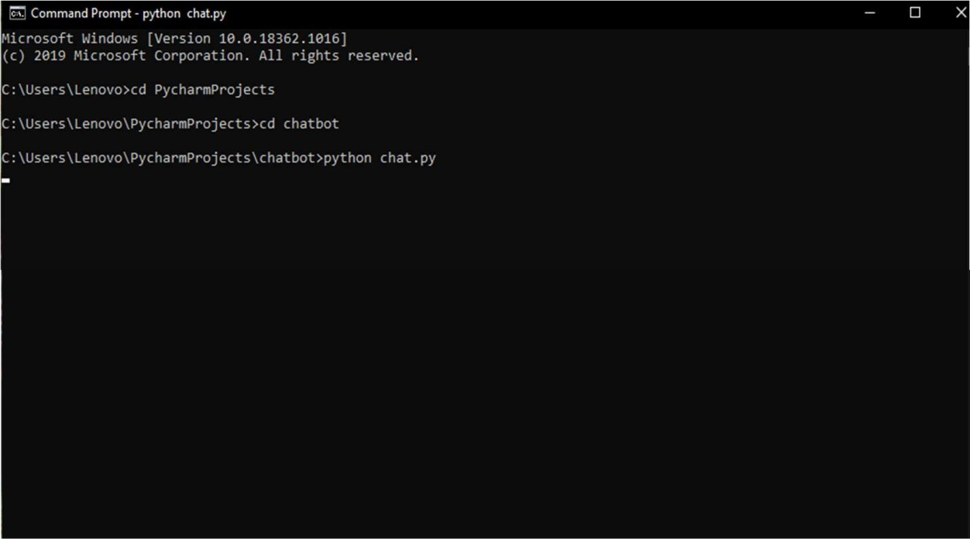

1. Commands in All In One Chatbot:

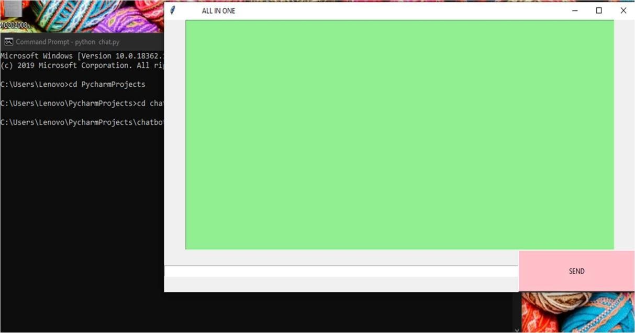

1. How to access related website using All In One Chatbot?

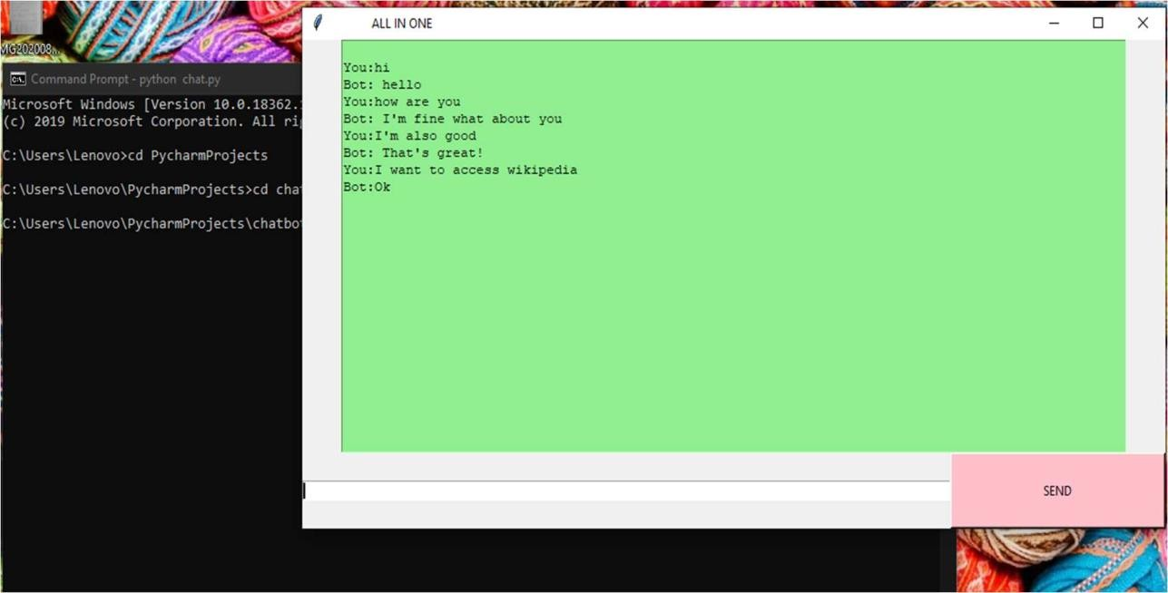

1. Accessing any website:

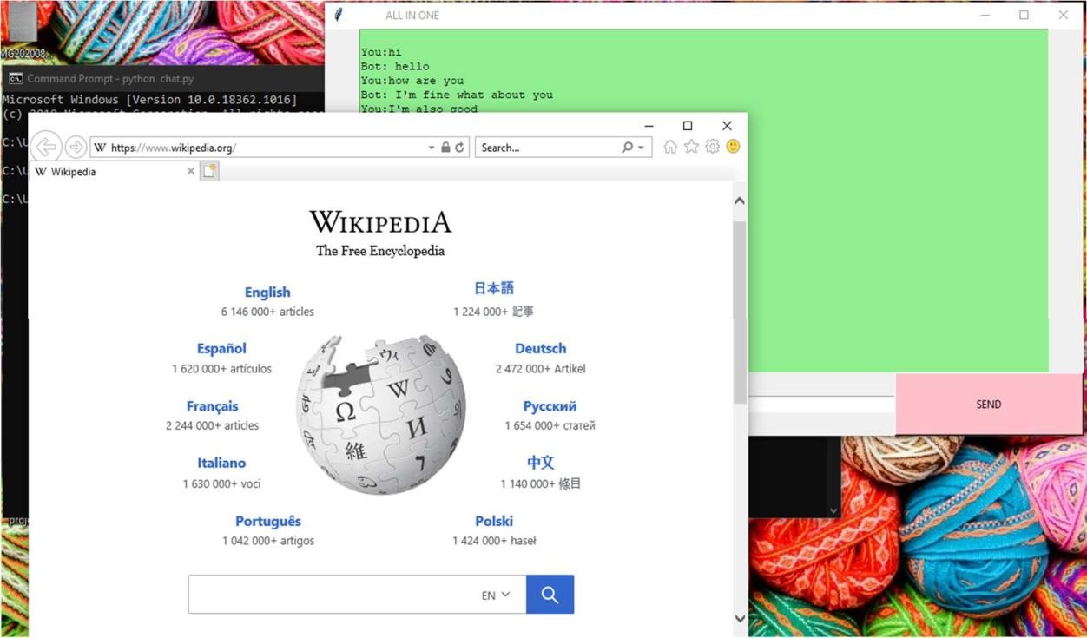

1. Accessing Google Classroom:

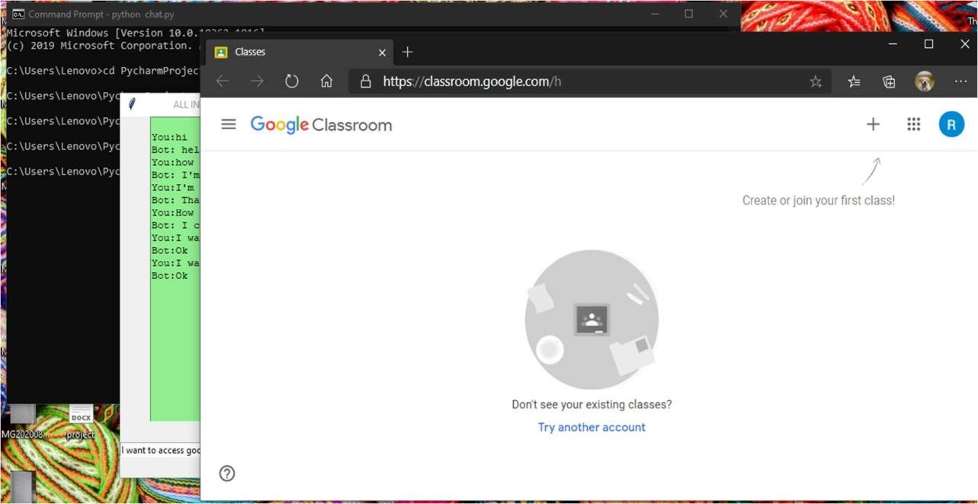

1. Accessing Phone-pe:

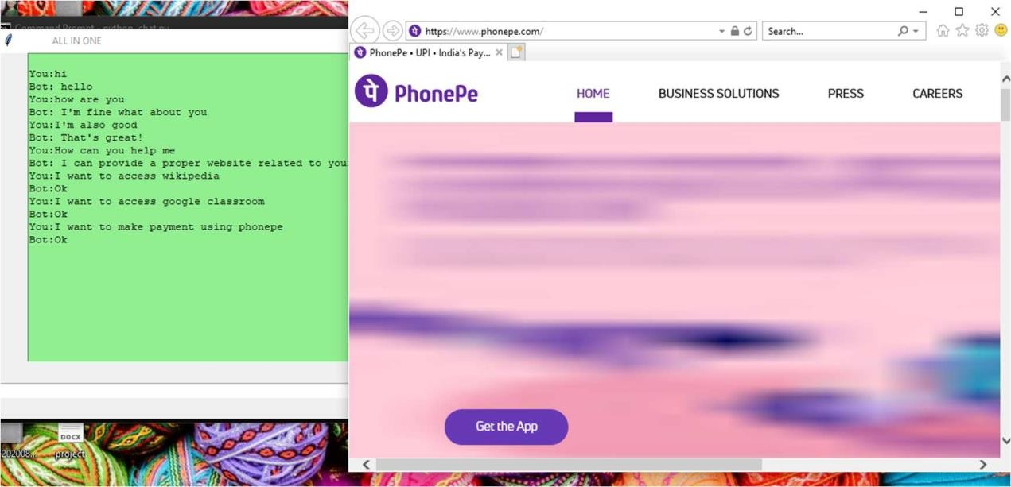

1. Accessing Game website:

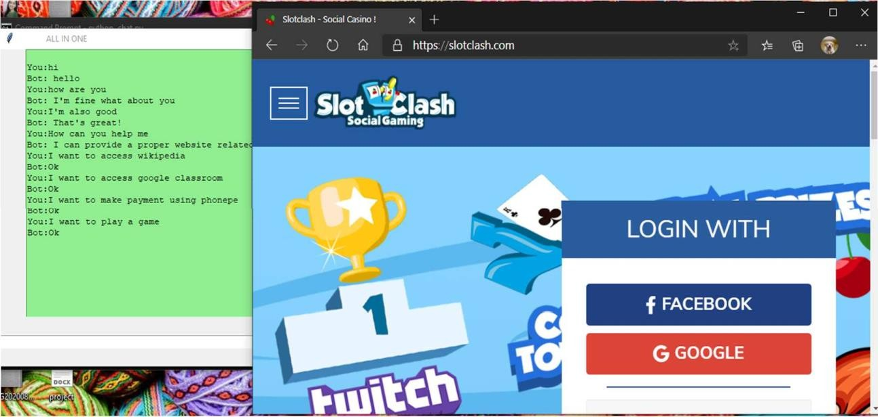

1. Accessing calculator:

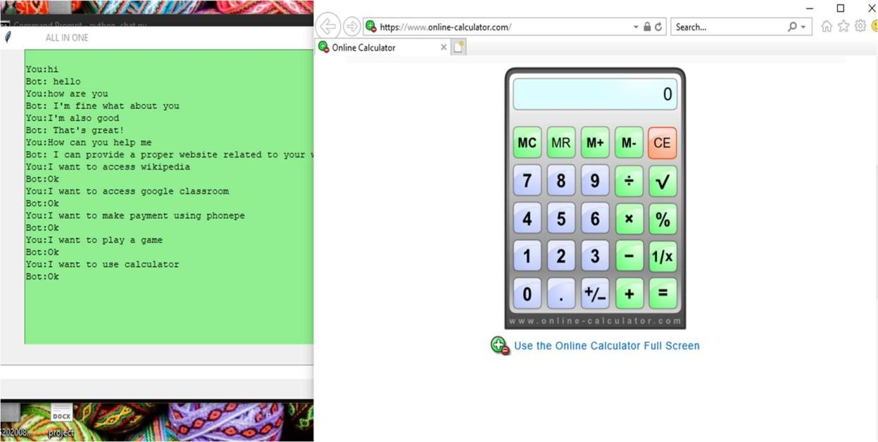

1. Ordering online food:

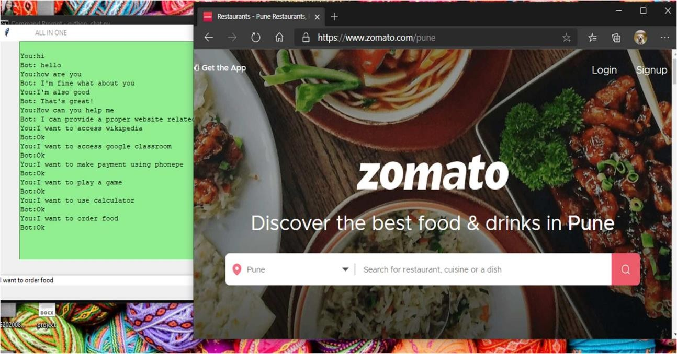

1. How to pay electricity bill:

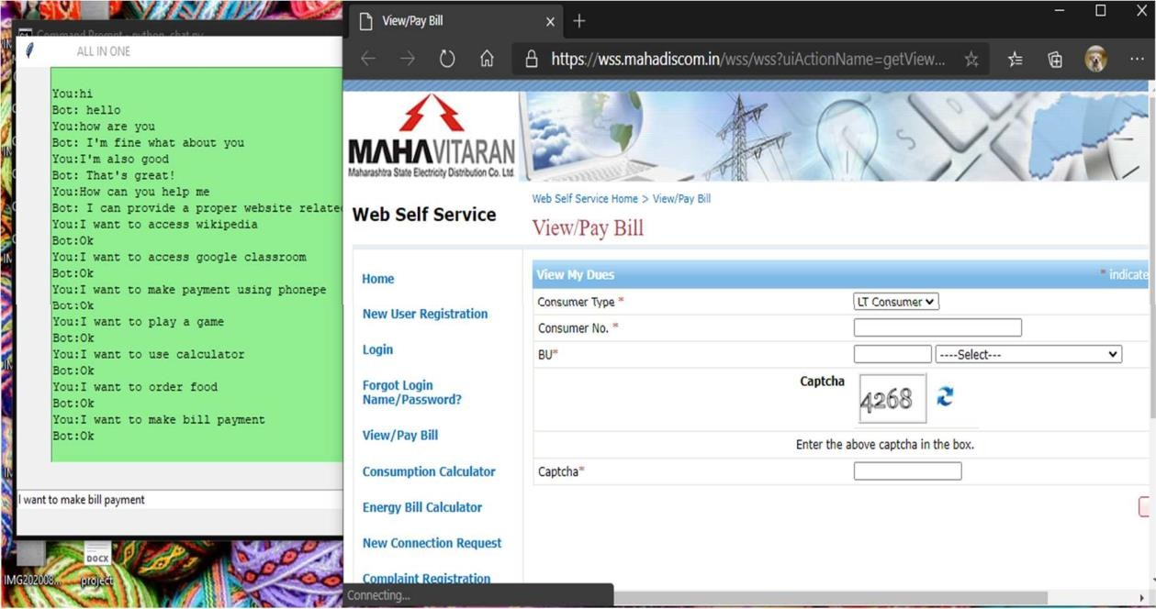

1. Accessing youtube:

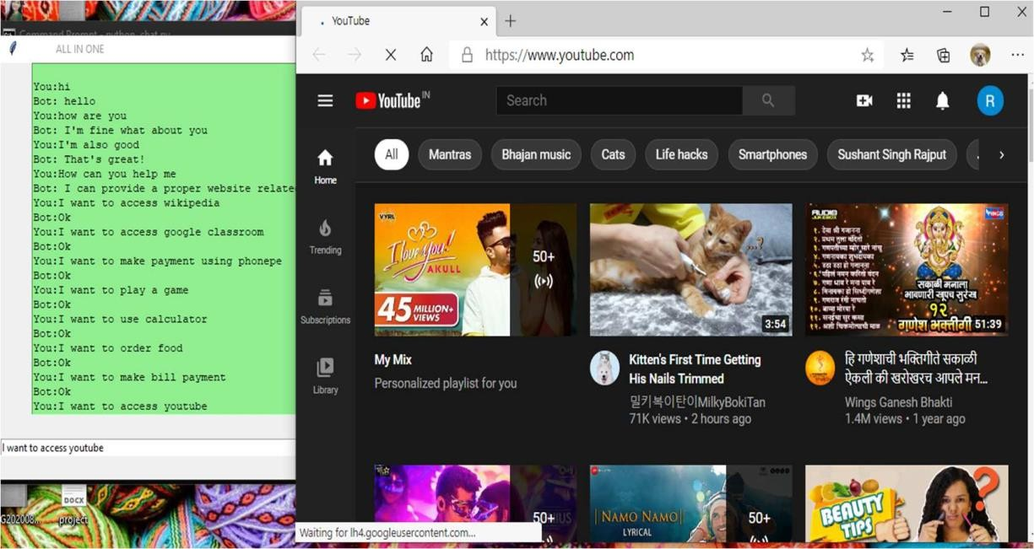

1. Accessing Social Media:

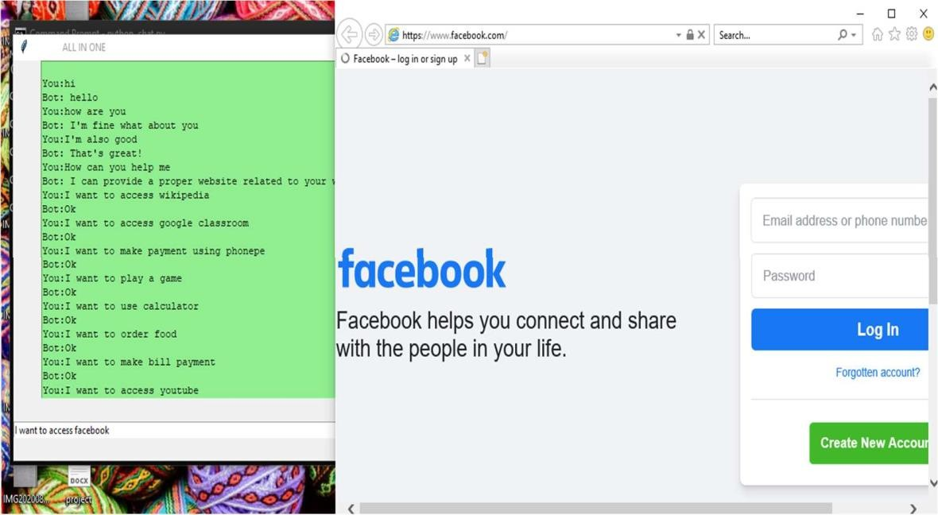

1. Accessing Social Media:

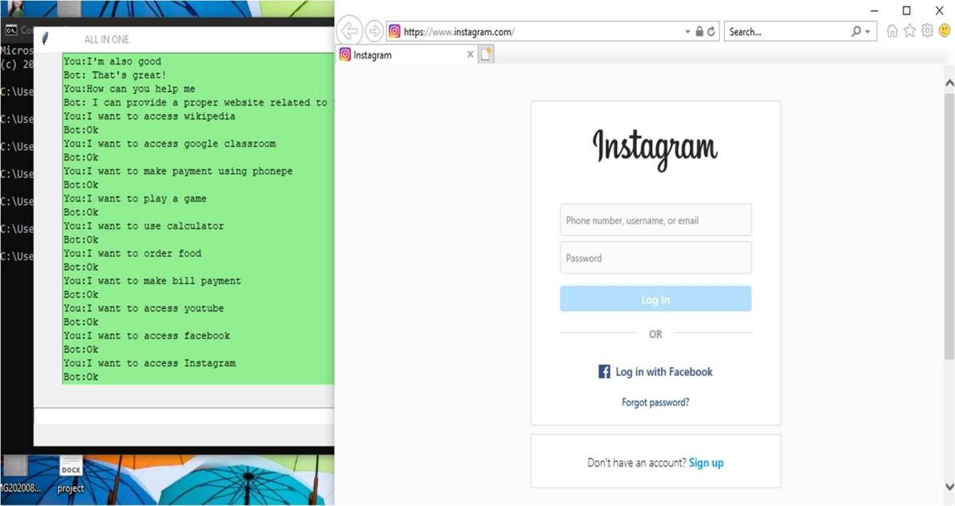

1. End Message:

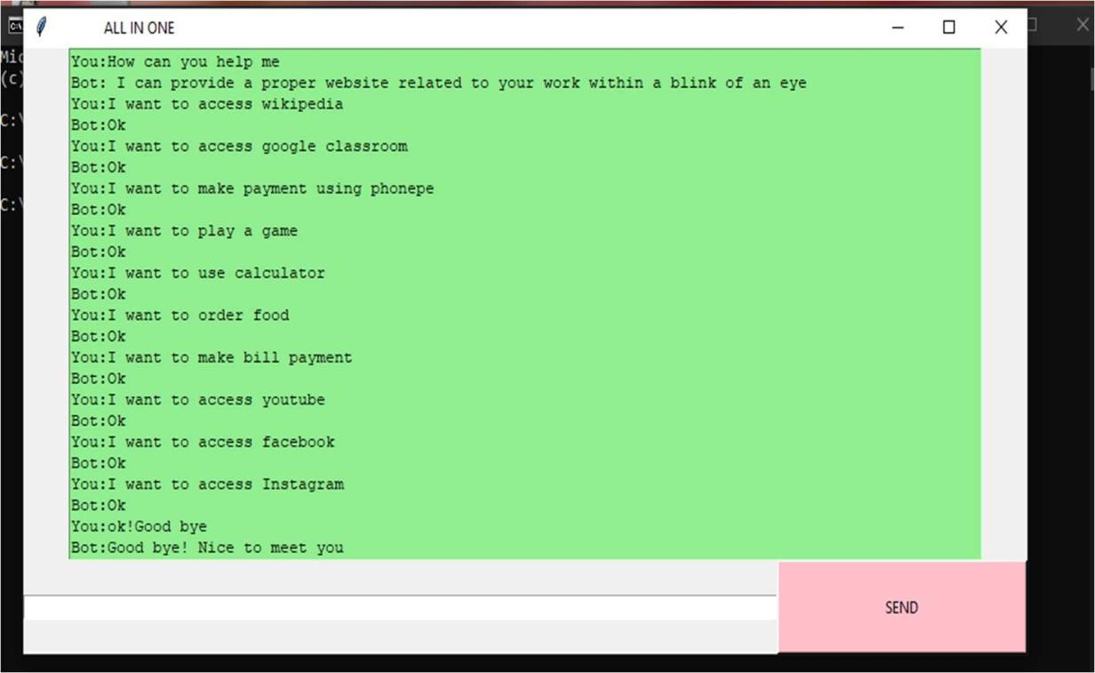

1. Error Message For wrong input:

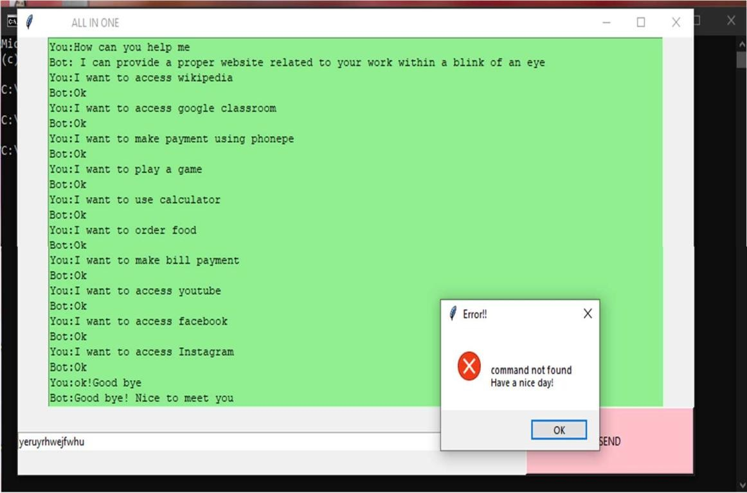

1. All In One Chatbot:

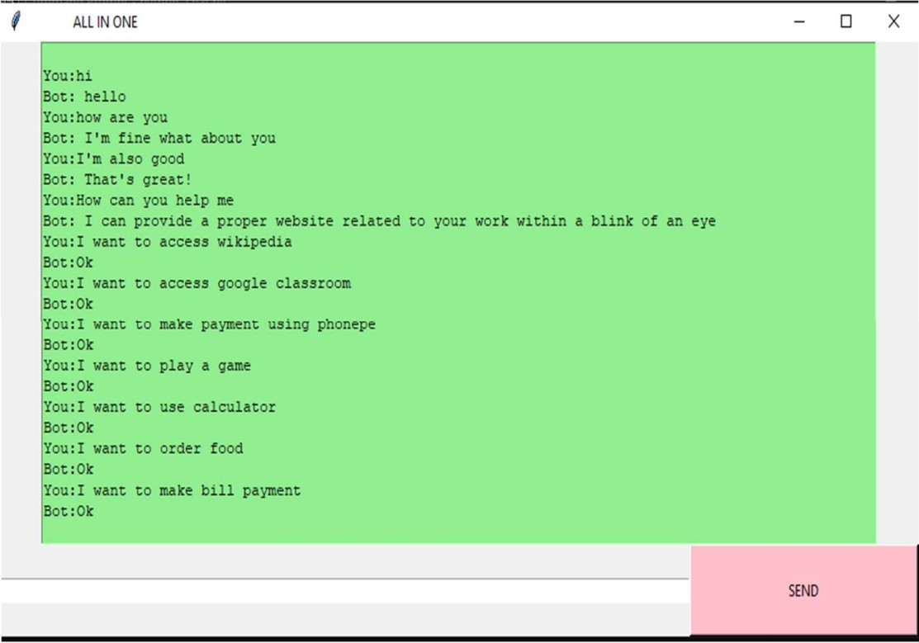

# Text code

from tkinter import * import webbrowser

from tkinter import messagebox root = Tk()

def send():

send = "You:"+ e.get() text.insert(END,"\n" + send) if(e.get()==ThiT):

text.insert(END, "\n" + "Bot: hello")

elif(e.get()==ThelloT): text.insert(END, "\n" + "Bot: hi")

elif (e.get() == Thow are youT):

text.insert(END, "\n" + "Bot: ITm fine what about you")

elif (e.get() == "ITm also good"): text.insert(END, "\n" + "Bot: ThatTs great!")

elif (e.get() == "How can you help me"):

text.insert(END, "\n" + "Bot: I can provide a proper website related to your work within a blink of an eye")

elif (e.get() == "ok!Good bye"):

text.insert(END, "\n" + "Bot:Good bye! Nice to meet you")

elif (e.get() == TI want to access wikipediaT):

text.insert(END,"\n" + "Bot:Ok", webbrowser.open("wikipedia.com"))

elif (e.get() == TI want to access googleT):

text.insert(END, "\n" + "Bot:Ok", webbrowser.open("google.com"))

elif (e.get() == TI want to access InstagramT):

text.insert(END, "\n" + "Bot:Ok", webbrowser.open("instagram.com"))

elif (e.get() == TI want to access youtubeT):

text.insert(END, "\n" + "Bot:Ok", webbrowser.open("youtube.com"))

elif (e.get() == TI want to access facebookT):

text.insert(END, "\n" + "Bot:Ok", webbrowser.open("facebook.com"))

elif (e.get() == TI want to access google classroomT): text.insert(END, "\n" + "Bot:Ok",

webbrowser.open("https://classroom.google.com/u/0"))

elif (e.get() == TI want to make payment using phonepeT): text.insert(END, "\n" + "Bot:Ok", webbrowser.open("phonepe.com"))

elif (e.get() == TI want to play a gameT):

text.insert(END, "\n" + "Bot:Ok", webbrowser.open("slotclash.com"))

elif(e.get() == TI want to use calculatorT):

text.insert(END, "\n" + "Bot:Ok", webbrowser.open("online- calculator.com"))

elif (e.get() == TI want to order foodT):

text.insert(END, "\n" + "Bot:Ok", webbrowser.open("zomato.com"))

elif (e.get() == TI want to make bill paymentT): text.insert(END, "\n" + "Bot:Ok",

webbrowser.open("https://wss.mahadiscom.in/wss/wss?uiActionName=getViewPayBil l"))

else:

messagebox.showerror("Error!!" ,"\n "

"command not found " " \n " "Have a nice day!")

text = Text(root,bg=Tlight greenT,width=100) text.grid(row=0,column=0,columnspan=3)

e = Entry(root,width=110)

send = Button(root,text=TSENDT,bg=TpinkT,width=30,height=4,command = send).grid(row=1,column=1)

e.grid(row=1,column=0)

root.title(T ALL IN ONE T) root.mainloop()

# References:

* + [www.wikipedia.com](http://www.wikipedia.com/)
  + [www.pycharm.com](http://www.pycharm.com/)
  + [www.chrome.com](http://www.chrome.com/)